Screens

Dashboard

The executive reporting dashboard allows for a quick overview and access to all reporting options. The dashboard is heavily customizable, the visibility of any report quick view being editable, as well as the size/arrangement of the dashboard panels. The panels themselves show all the reports available for that category, as well as a list of overall daily statistics to quickly identify any issues or breakdowns.

It will also allow access to the report scheduler, which enables customized, filtered reports to be sent out on a consistent schedule.

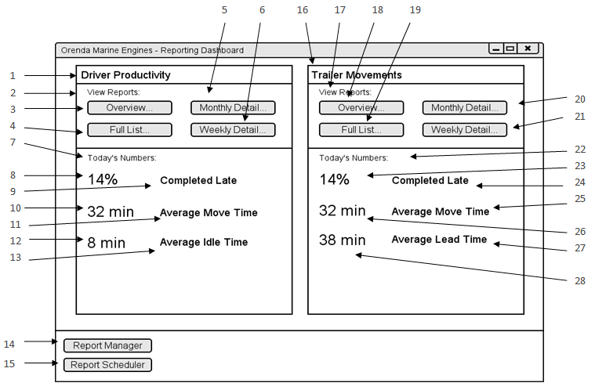

|  |  |  |  |
| --- | --- | --- | --- |
| # | Type | Text | Functions/Notes |
| 1 | Label | Driver Productivity | Report Title |
| 2 | Label | View Reports: |  |
| 3 | Button | Overview… | Brings up dialog to select reporting period, and to run or schedule report.  This report shows the overall statistics for all drivers selected in the time period selected. |
| 4 | Button | Full List… | Brings up dialog to select reporting period, and to run or schedule report.  This report shows all moves for the selected driver for the reporting period, subtotalled by week and month. |
| 5 | Button | Monthly Detail… | Brings up dialog to select reporting period, and to run or schedule report.  This report shows the average statistics for a selected driver by month, subtotalled by year. |
| 6 | Button | Weekly Detail… | Brings up dialog to select reporting period, and to run or schedule report.  This report shows the average statistics for a selected driver by week, subtotalled by month and year. |
| 7 | Label | Today’s Numbers: |  |
| 8 | Live Statistic Label | <Varies> | This label updates periodically based on live data. |
| 9 | Label | Completed Late |  |
| 10 | Live Statistic Label | <Varies> | This label updates periodically based on live data. |
| 11 | Label | Average Move Time |  |
| 12 | Live Statistic Label | <Varies> | This label updates periodically based on live data. |
| 13 | Label | Average Idle Time |  |
| 14 | Button | Report Manager | This button brings up the Report Manager screen, allowing the user to customize what is displayed on the dashboard, and other options associated with the reports. |
| 15 | Button | Report Scheduler | This button brings up the Report Scheduler screen, allowing the user to manage scheduled reports, add/update/remove/etc. |
| 16 | Label | Trailer Movements |  |
| 17 | Label | View Reports: |  |
| 18 | Button | Overview… | Brings up dialog to select reporting period, and to run or schedule report.  This report shows the overall statistics for all four docks in the time period selected. |
| 19 | Button | Full List… | Brings up dialog to select reporting period, and to run or schedule report.  This report shows all moves to and from a specific dock for the reporting period, subtotalled by week and month. |
| 20 | Button | Monthly Detail… | Brings up dialog to select reporting period, and to run or schedule report.  This report shows the average statistics for a specific dock by month, subtotalled by year. |
| 21 | Button | Weekly Detail… | Brings up dialog to select reporting period, and to run or schedule report.  This report shows the average statistics for a specific dock by week, subtotalled by month and year. |
| 22 | Label | Today’s Numbers: |  |
| 23 | Live Statistic Label | <Varies> | This label updates periodically based on live data. |
| 24 | Label | Completed Late |  |
| 25 | Label | Average Move Time |  |
| 26 | Live Statistic Label | <Varies> | This label updates periodically based on live data. |
| 27 | Label | Average Lead Time |  |
| 28 | Live Statistic Label | <Varies> | This label updates periodically based on live data. |

Report Manager

The report manager will show a list of all reports, with options to add the quick view panel to the dashboard. The visibility of each individual report from a category is also customizable. From this screen, each report can be run or scheduled.

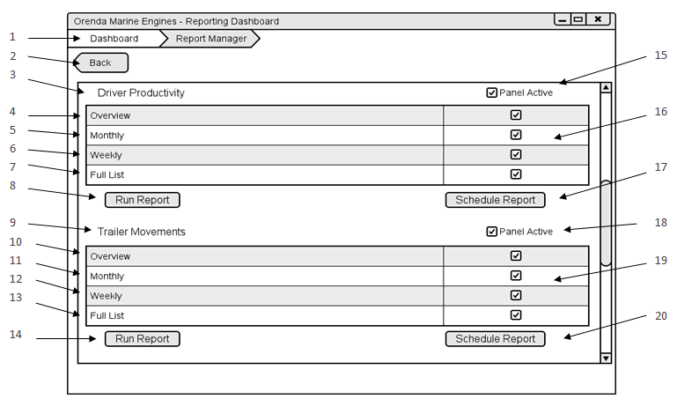

|  |  |  |  |
| --- | --- | --- | --- |
| # | Type | Text | Functions/Notes |
| 1 | Breadcrumb Menu | Dashboard > Report Manager | The user can click on the relevant breadcrumb and be brought back to that view. |
| 2 | Button | Back | Brings the user back one page. |
| 3 | Label | Driver Productivity |  |
| 4 | Label | Overview |  |
| 5 | Label | Monthly |  |
| 6 | Label | Weekly |  |
| 7 | Label | Full List |  |
| 8 | Button | Run Report | Runs the selected report for that subsection. |
| 9 | Label | Trailer Movements |  |
| 10 | Label | Overview |  |
| 11 | Label | Monthly |  |
| 12 | Label | Weekly |  |
| 13 | Label | Full List |  |
| 14 | Button | Run Report | Runs the selected report for that subsection. |
| 15 | Check box | Panel Active | Determines if the panel containing that report is visible from the dashboard |
| 16 | Check boxes |  | Determines if each corresponding report is available to be run. |
| 17 | Button | Schedule Report | Brings up the report scheduling dialog, and allows the user to schedule a report. |
| 18 | Check box | Panel Active | Determines if the panel containing that report is visible from the dashboard |
| 19 | Check Boxes |  | Determines if each corresponding report is available to be run. |
| 20 | Button | Schedule Report | Brings up the report scheduling dialog, and allows the user to schedule a report. |

Report Scheduler

The report scheduler allows the user to manage, edit, and view all the currently scheduled reports as well as schedule new reports. The view shows the name of the report, the frequency, the dates or days of the week, and the users to whom the reports will be sent.

If a report is added to the schedule from the report scheduler, then the report must be selected from the list. However, if the report is scheduled from a report view, or a view other than the report scheduler, then it is automatically populated into the report selection list. Editing a report uses an identical interface, for ease of operation.

Scheduled reports allow an increase in efficiency for the reporting process. Reports are simple to create in the first place, and a regularly scheduled report directly to the executive inbox is easy, convenient, and doesn’t require any additional effort.

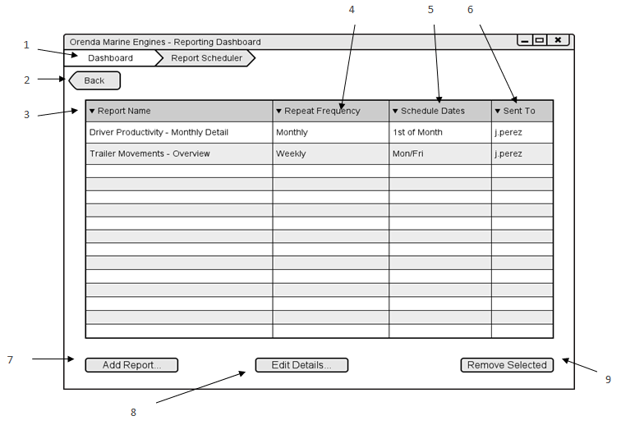

|  |  |  |  |
| --- | --- | --- | --- |
| # | Type | Text | Functions/Notes |
| 1 | Breadcrumb Menu | Dashboard > Report Scheduler | The user can click on the relevant breadcrumb and be brought back to that view. |
| 2 | Button | Back | Brings the user back one page. |
| 3 | Grid Column | Report Name | Displays the title of the report. If clicked, sorts alphabetically. |
| 4 | Grid Column | Repeat Frequency | Shows how often the report is repeated. |
| 5 | Grid Column | Schedule Dates | Shows the relative dates or days of the week that the report is scheduled for. |
| 6 | Grid Column | Sent To | Shows the user IDs of who the report gets sent to. |
| 7 | Button | Add Report… | Opens up the add report dialog, allowing the user to schedule a report. |
| 8 | Button | Edit Details… | Opens the edit report dialog. Essentially the add report dialog, but with the selected report details prepopulated. |
| 9 | Button | Remove Selected | Removes the selected report from the schedule. |

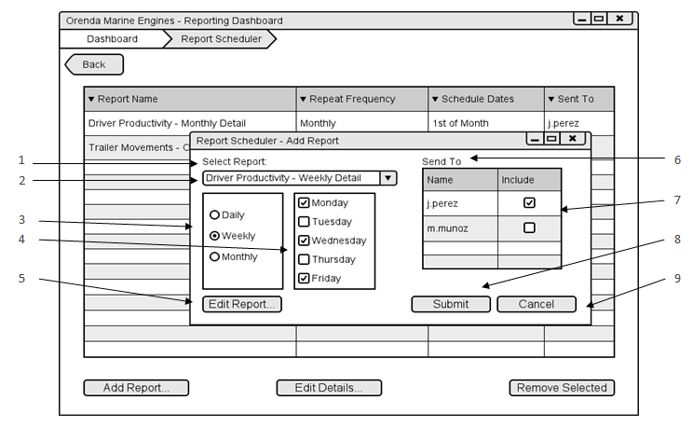

|  |  |  |  |
| --- | --- | --- | --- |
| # | Type | Text | Functions/Notes |
| 1 | Label | Select Report |  |
| 2 | Combobox | <Varies – Report names> | Combobox of all available reports, arranged in a tree structure |
| 3 | Radio Buttons | Daily/Weekly/Monthly | Repeating period for the report, changes the controls in #4. |
| 4 | Check Boxes or Date picker | <Varies – Dates, weekdays, or times> | Varies depending on #3, lets the user pick the days, times, or dates that the report will send in the repeating period. |
| 5 | Button | Edit Report… | Brings the user to a modified Report view, where they can select filters for the scheduled report. |
| 6 | Label | Send To |  |
| 7 | Check Boxes | <Varies – User Names> | Lists the usernames of anyone with permission to receive the report. |
| 8 | Button | Submit | Closes the dialog, and saves the scheduled report to the system. |
| 9 | Button | Cancel | Closes the dialog, and does not save the report. |

Report View

The report view screen shows the paged report, with a panel of relevant filters. There is a filter for each parameter of the report. From this view a report can be exported, either printed or as a file.

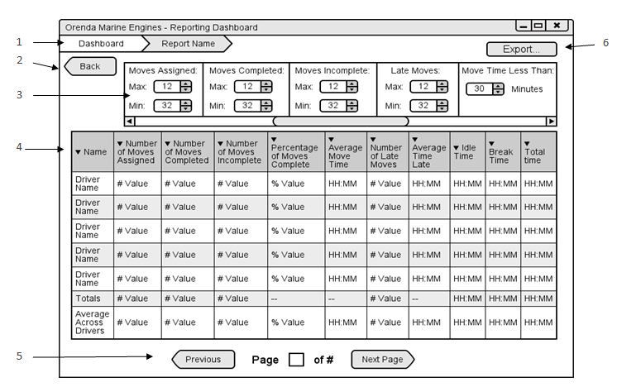

|  |  |  |  |
| --- | --- | --- | --- |
| # | Type | Text | Functions/Notes |
| 1 | Breadcrumb Menu | Dashboard > <Report Name> | The user can click on the relevant breadcrumb and be brought back to that view. |
| 2 | Button | Back | Brings the user back one page. |
| 3 | Filter Panel | <Varies> | Depending on the report, there will be a list of relevant filters and selection criteria. Each column on the report and each parameter will have a default value, but they will be all searchable, selectable, and modifiable. |
| 4 | Report View | <Varies> | Column-based view of the chosen report, columns vary depending on report chosen. |
| 5 | Page Selection | Previous, Page <Current> of <Total>, Next | Page selection, shows the current page, the total number of pages, and buttons for the next and previous page (disabled if at start or end). The current page is also a text entry field, to allow the user to jump to any given page at will. |
| 6 | Button | Export… | Brings up a dialog for export options, including printing, and exporting as a file (XLS, PDF, etc). |

Reports

Driver Productivity Report

The driver productivity report shows an overall view for each driver, averaged over the reporting period. This report also includes the totals and averages across all drivers.

This report can be sorted for each metric, and used as a tool to identify an overall comparison for each driver against the average.

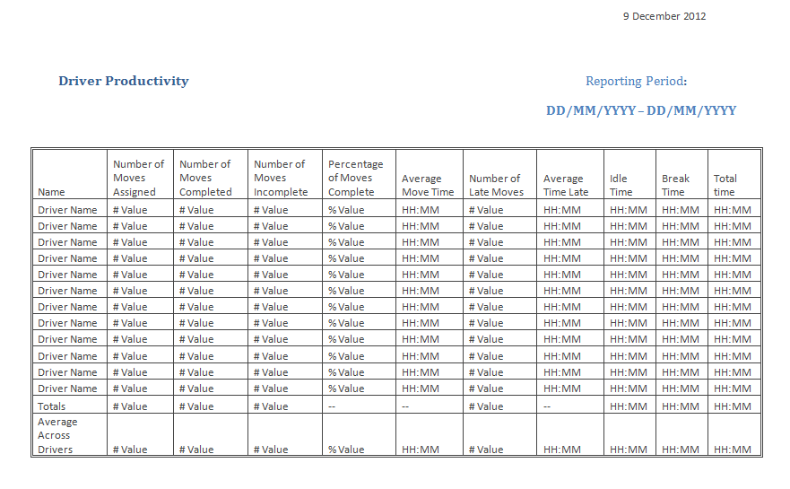

Individual Productivity Report – Full View

This report allows a detailed view of a driver’s movements and statistics. Each move is listed, along with weekly summaries and averages, as well as monthly of the same.

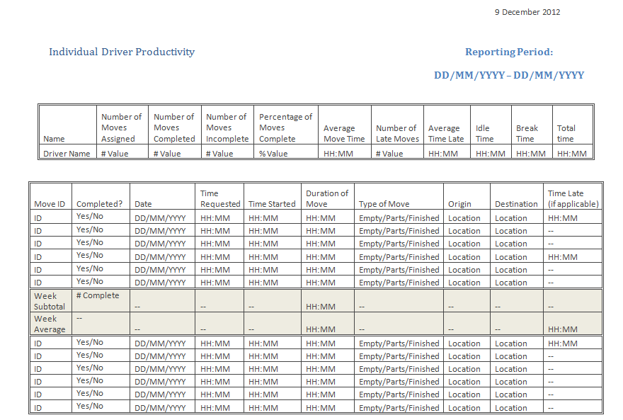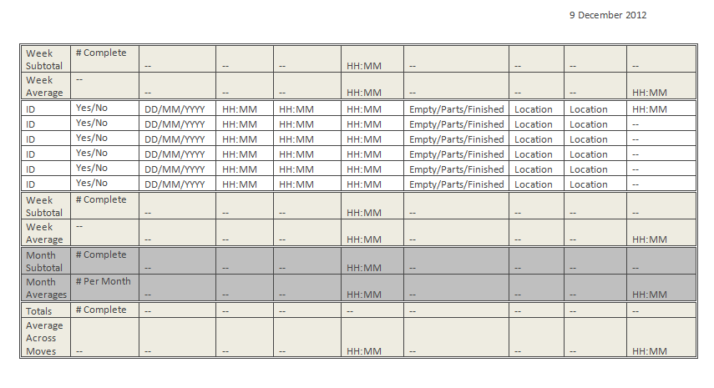

Driver Daily, Weekly, and Monthly Detail

In addition to the individual report, there are daily, weekly and monthly breakdowns, which will serve to show the driver’s behavior over a longer period of time. Reporting over a longer and longer time periods begins to get unwieldy with the individual reports, as there are many hundreds of moves involved. These reports let broad trends over time be tracked.

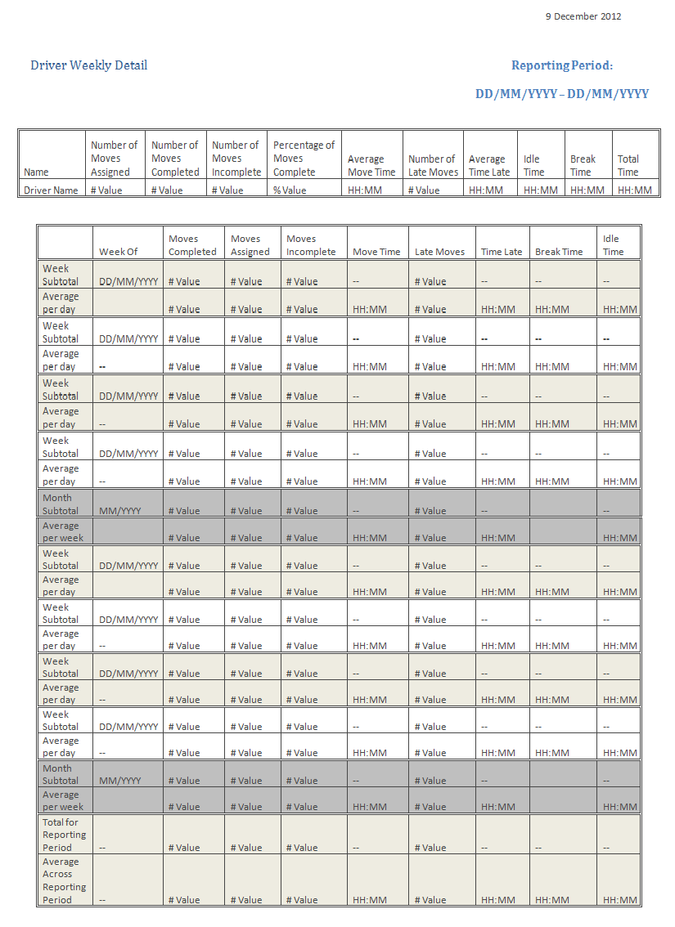

Trailer Movements

This report is similar to the driver productivity report, but its metrics are tied to the docks overall, rather than to individual drivers. This report would be useful for isolating problems stemming from requests, rather than from driver responses.

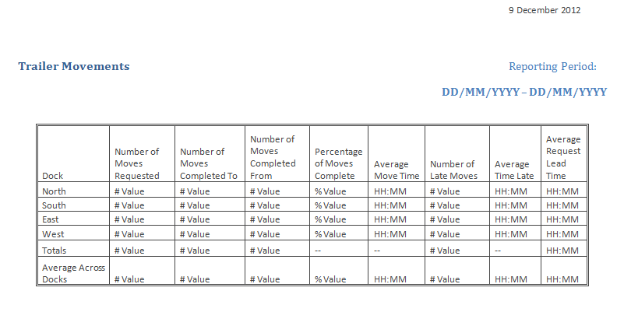

Trailer Movements by Dock

As the Individual Driver Productivity report shows all moves for the driver, this report shows all movements to and from any selected dock.

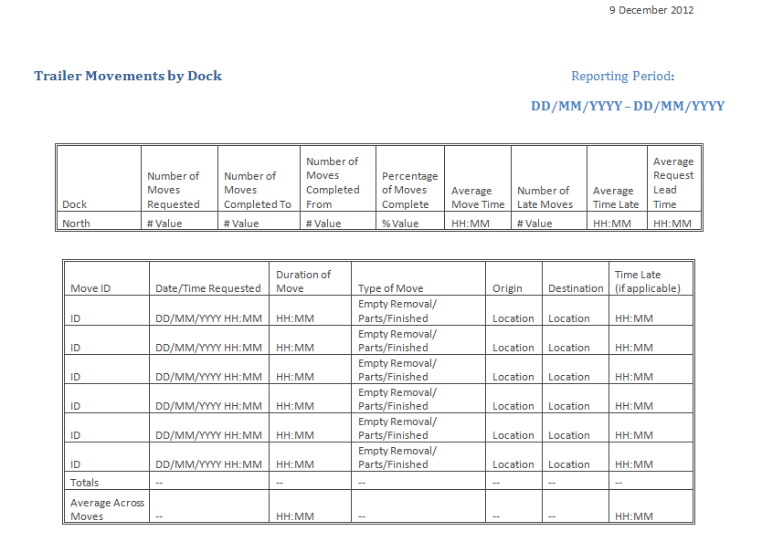

Trailer Movements Daily, Weekly, and Monthly Details

A similar detailed view, these reports will track the trends of movements to and from the selected dock over the reporting period.

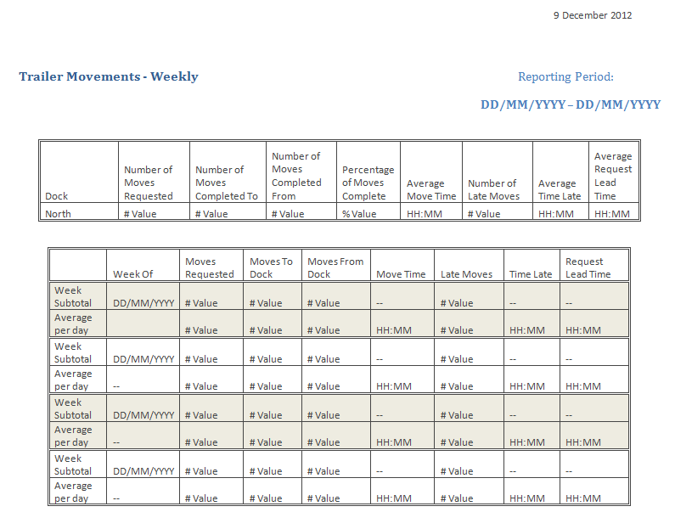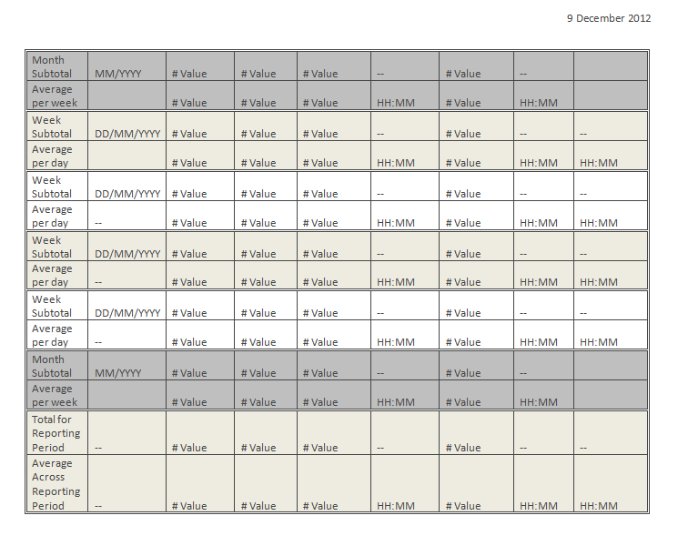

Dock Statistics

This report is an alternate way of viewing movements to and from the docks. It focuses on the requests originating from the docks themselves, rather than the trailer movements to and from.

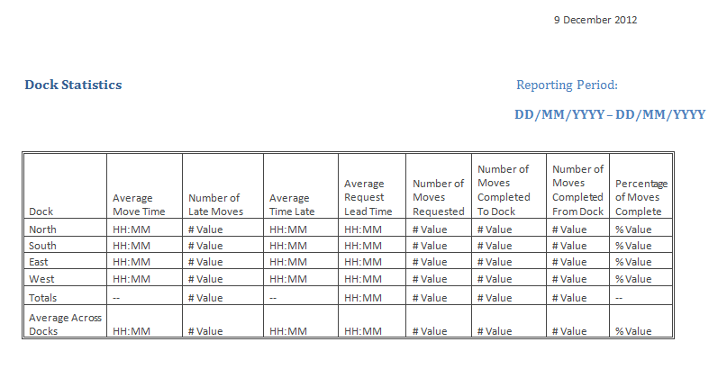

Arrivals and Departures

The arrivals and departures report is tied into the order and inventory management. It tracks the arrivals of orders based on the Purchase Order number, and if there is an associated departure, then this is indicated along with the Bill of Lading number and departure time.

